

**3rd year 2nd semester B. Sc. (Hons.) Final Examination -2021**

ICT-3200: Project Work-III

**Emotion Detection Using Artificial Intelligence**

**Project Supervisor**

Dr. Md. Sazzadur Rahman

Associate Professor

Institute of Information Technology

Jahangirnagar University

**Prepared by-**

|  |  |
| --- | --- |
| **Name** | **Exam Roll** |
| Keya Biswas | 192288 |
| Meher Afrose Shaon | 192307 |
| Zamshed Iqbal Forman | 192314 |
| Md. Maruful Islam Maruf | 192323 |

**Institute of Information Technology**

**Jahangirnagar University**

**Savar, Dhaka-1324, Bangladesh**

**DECLARATION**

This project report is submitted to the Institute of Information Technology, Jahangirnagar University, Savar, Dhaka in partial fulfillment of the requirements for having the B.Sc (Hons.) degree in ICT. This is also needed to certify that the project work is under the 3rd Year 2nd Semester course of the IIT “ICT-3200: Project Work-III”. So, we are here declaring that this project report has not been submitted elsewhere for the requirement of any kind of degree, diploma or publication.

**ACCEPTANCE**

This project report is submitted to the Institute of Information Technology, Jahangirnagar University, Savar, Dhaka in partial fulfillment of the requirements for having the B.Sc (Hons.) degree in Information and Communication Technology.

**_____________________________**

**Dr. Md. Sazzadur Rahman**

Associate Professor

Institute of Information Technology,

Jahangirnagar University, Savar, Dhaka -1342, Bangladesh.

**ACKNOWLEDGEMENTS**

First of all, we want to thank the Almighty for giving us the opportunity to complete this work successfully. Our acknowledgement is meant to express our thankfulness to all the persons who helped us by sharing their experiences and amazed us with their personal opinions to make our project a better one. We are thankful to our parents for their continuous support. Most importantly we are grateful to our honorable supervisor, **Dr. Md. Sazzadur Rahman** Sir who helped us by monitoring each step we have taken to make our project work and provided us with all the necessary materials and sufficient knowledge that was the major requirement.

Finally, we convey our gratitude and felicitation to our honorable teacher and project supervisor

**Dr. Md. Sazzadur Rahman** sir for giving us the opportunity to learn practically and implement it into ourproject.

**ABSTRACT**

The Emotion Detection using Artificial Intelligent project is an application of computer vision and deep learning techniques to detect human emotions in real-time. The project involves training a deep learning model using a dataset of labeled facial expressions, and integrating it with OpenCV to capture live video frames from a webcam and perform real-time emotion analysis. The project has several potential applications in fields such as healthcare, marketing, and entertainment. This report provides a detailed overview of the project, including the dataset used, the deep learning model architecture, and the integration of OpenCV. The project's accuracy and reliability are also evaluated through testing and experimentation.

Table of Contents

Chapter 1 7

Introduction 7

1.1 Project Overview 7

1.1.1 Main Features at A Glance 7

1.2 Project Purpose 7

1.2.1 Motivations 8

1.2.2 Objectives 8

Chapter 2 9

Methodology 9

2.1 Components 9

2.4 Flowchart 10

2.5 Working Procedure 10

Chapter 3 11

Experiment Analysis 11

3.1 Output 11

3.2 Source code 13

3.2.1 Google CoLab code: 13

3.2.2 Driver code: 16

3.3 Result 17

3.4 Limitations 17

Chapter 4 18

Conclusion and Future Work 18

4.1 Conclusion 18

4.2 Future Work 18

References 19

# Chapter 1

# Introduction

## 1.1 Project Overview

The Emotion Detection[5] using Artificial Intelligent project involves the use of computer vision and deep learning techniques to detect human emotions in real-time. The project aims to create an efficient and reliable emotion detection system that can be used in various applications such as healthcare, marketing, and entertainment. The project involves collecting and preprocessing a dataset of labeled facial expressions, training a deep learning model using popular frameworks such as TensorFlow[2] or PyTorch, and integrating it with OpenCV to perform real-time analysis on live video frames. This report provides a detailed overview of the project, including the methodology, the dataset used, the deep learning model architecture, and the integration of OpenCV. The report also evaluates the project's accuracy and reliability through testing and experimentation.

### 1.1.1 Main Features at A Glance

The main features of our project are –

* Real-time emotion detection[5]
* Customizable and adaptable
* User-friendly interface
* High-performance deep learning model
* Efficient and cost-effective

## 1.2 Project Purpose

The purpose of this Emotion Detection[5] using Artificial Intelligent project is to develop an accurate and reliable system for real-time emotion detection using computer vision and deep learning techniques. The project aims to provide a valuable tool for industries such as healthcare, marketing, and entertainment that require real-time emotion analysis. The system will be designed to be customizable and adaptable to various use cases, providing a versatile solution for a range of applications. The project's ultimate goal is to provide an accessible and effective tool for real-time emotion detection that can benefit a broad range of fields and industries.

### 1.2.1 Motivations

The Emotion Detection using OpenCV[1] & Python project aims to address the need for real-time emotion analysis in industries such as healthcare, marketing, and entertainment. Existing emotion detection systems can be expensive and complicated to use, which limits their accessibility and practicality. By developing a customizable and adaptable system that utilizes computer vision and deep learning techniques, the project seeks to provide an affordable and effective solution to this challenge.

### 1.2.2 Objectives

The objectives of the project are-

* Developing a deep learning model for accurate emotion detection[5]
* Optimizing the system for real-time performance
* Creating a user-friendly interface
* Testing and evaluation
* Documentation and dissemination

# Chapter 2

# Methodology

## 2.1 Components

The required components for the projects are -

* Dataset
* Programming language
* Machine learning library
* Data preprocessing tools
* Feature extraction tools
* Algorithm selection
* Hyperparameter tuning
* Model evaluation tools
* Deployment platform

## 

## 2.4 Flowchart

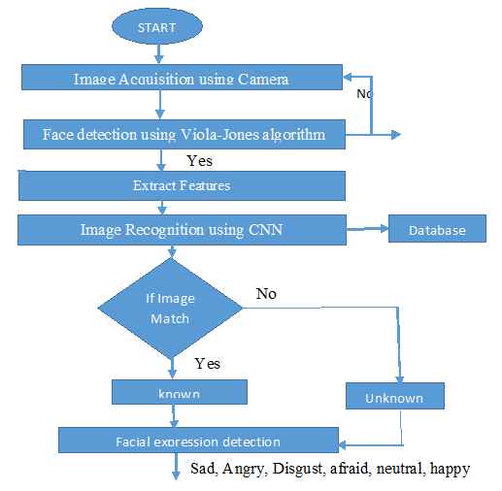

## 2.5 Working Procedure

* Data collection
* Preprocessing
* Feature extraction
* Model training
* Model evaluation
* Real-time emotion detection
* System optimization
* Documentation
* Demonstration
* Iteration

# Chapter 3

# Experiment Analysis

## 3.1 Output

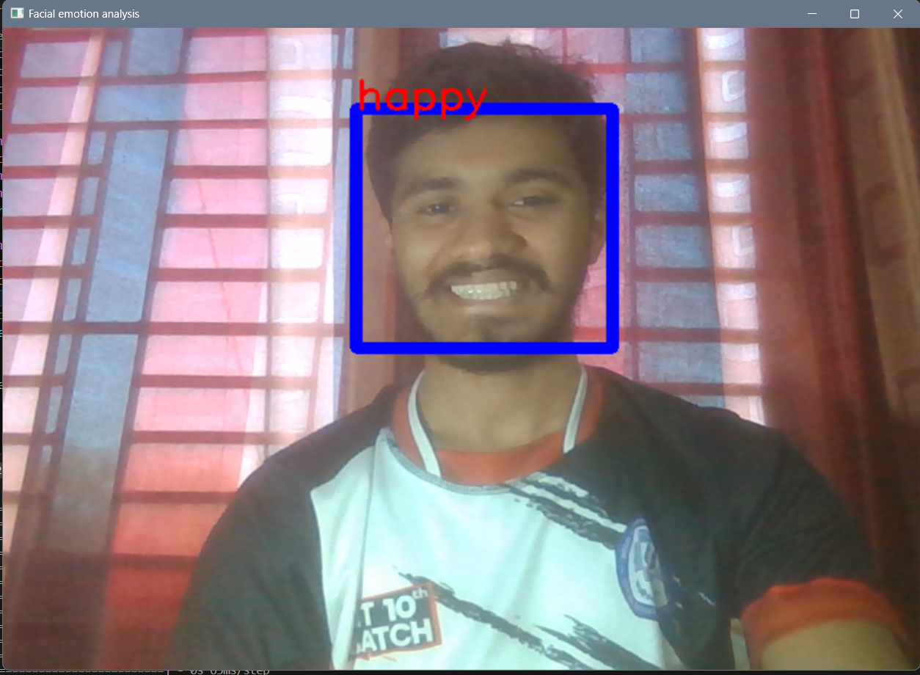

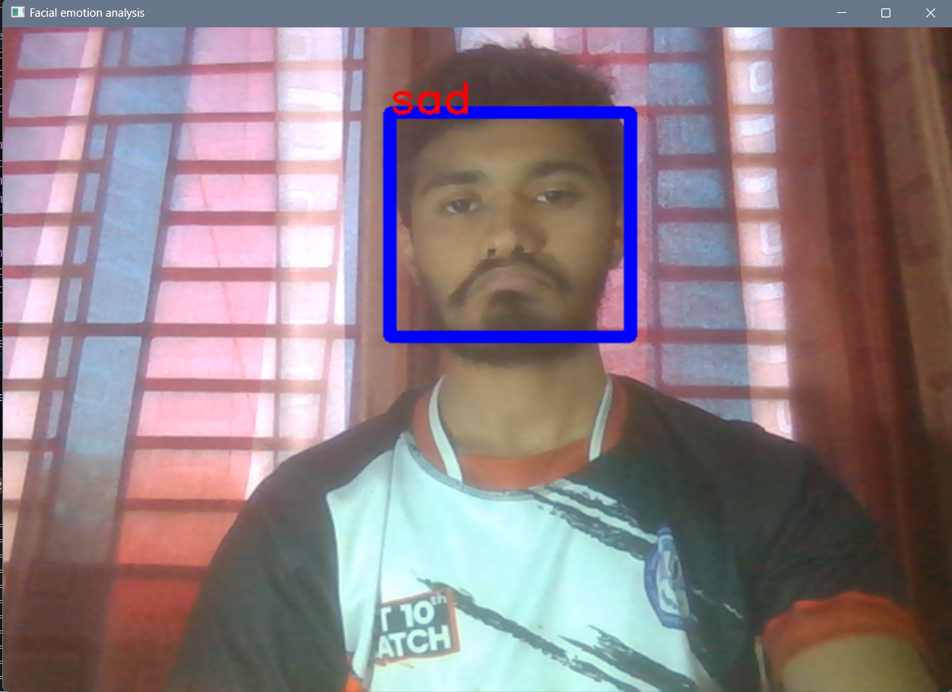

## 3.2 Source code

### 3.2.1 Google CoLab code:

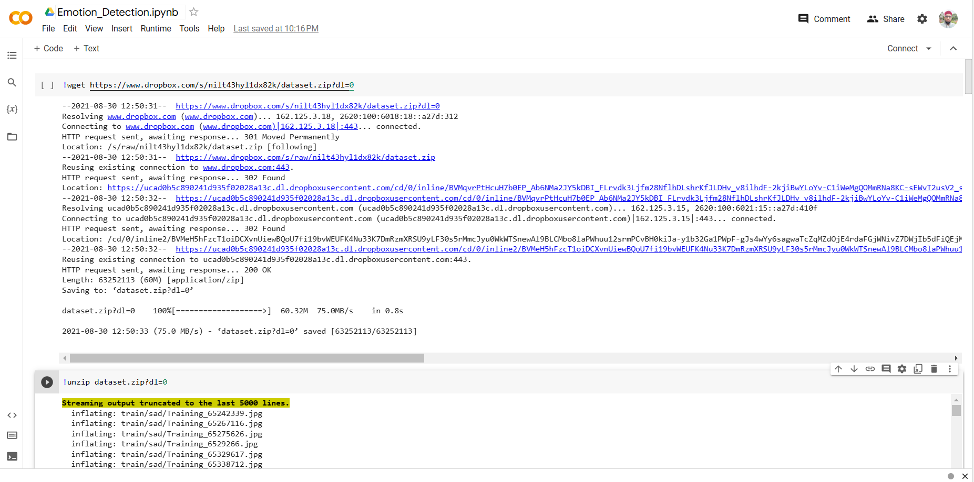

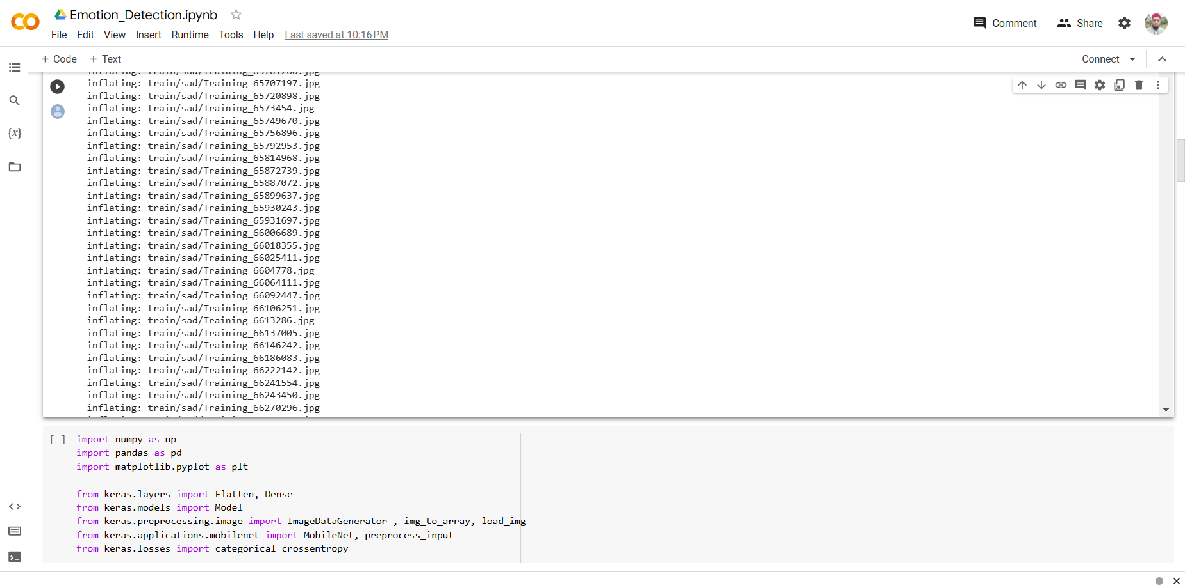

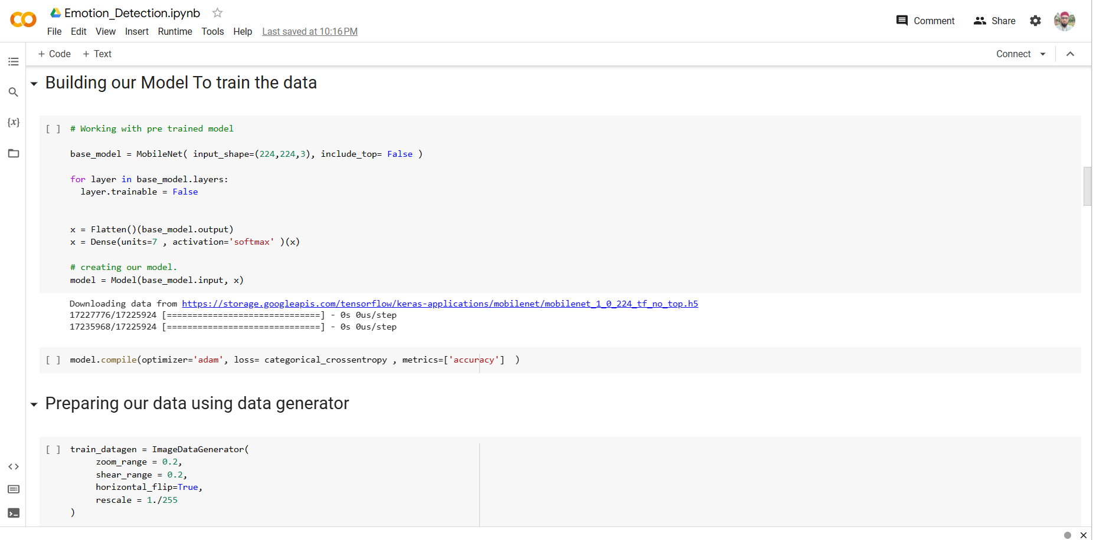

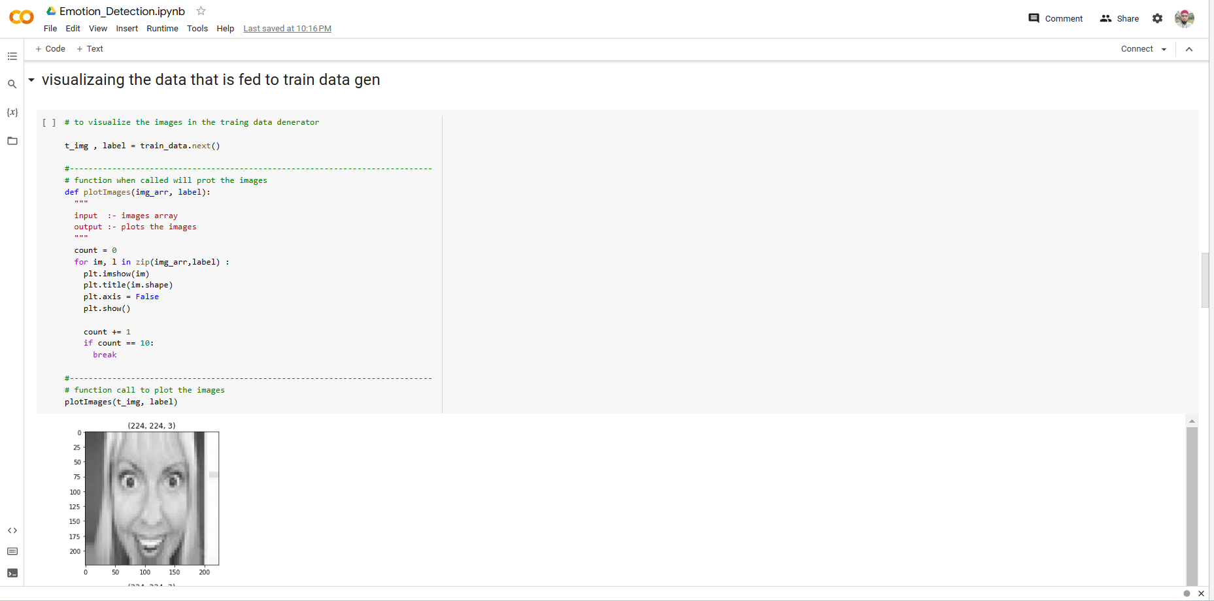

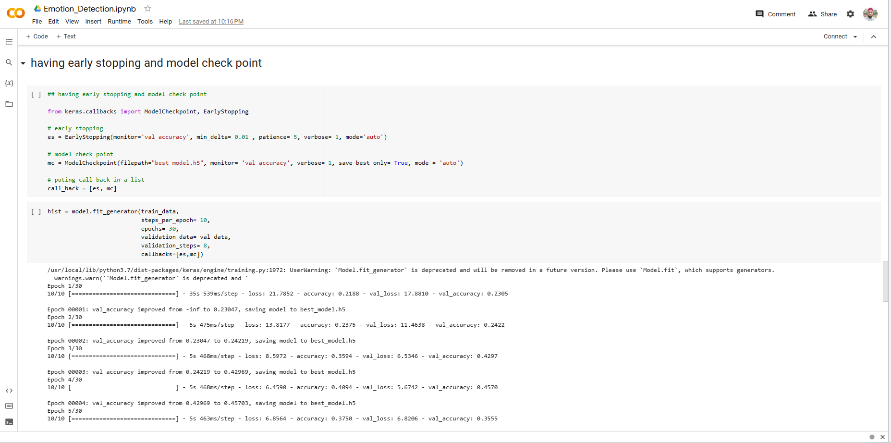

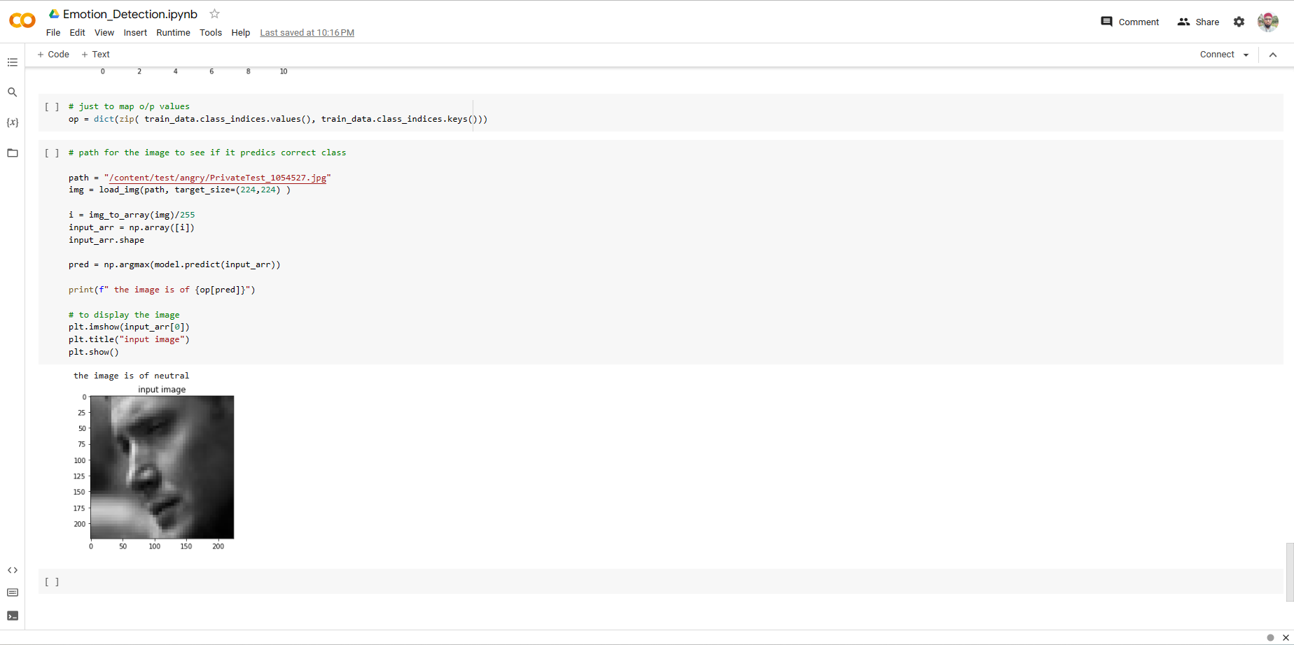

### 3.2.2 Driver code:

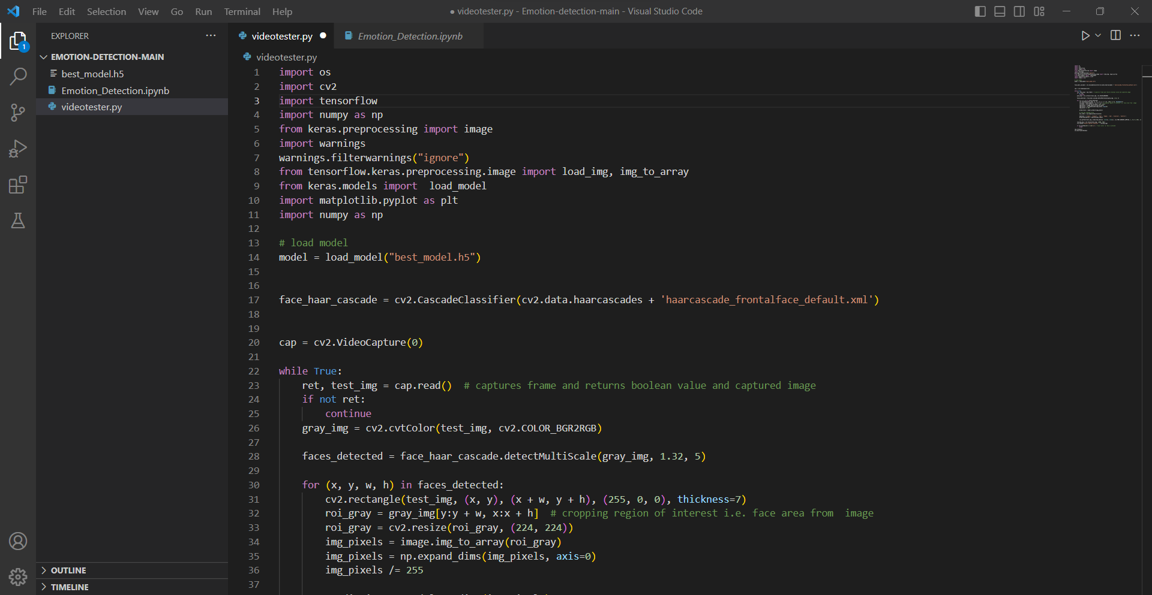

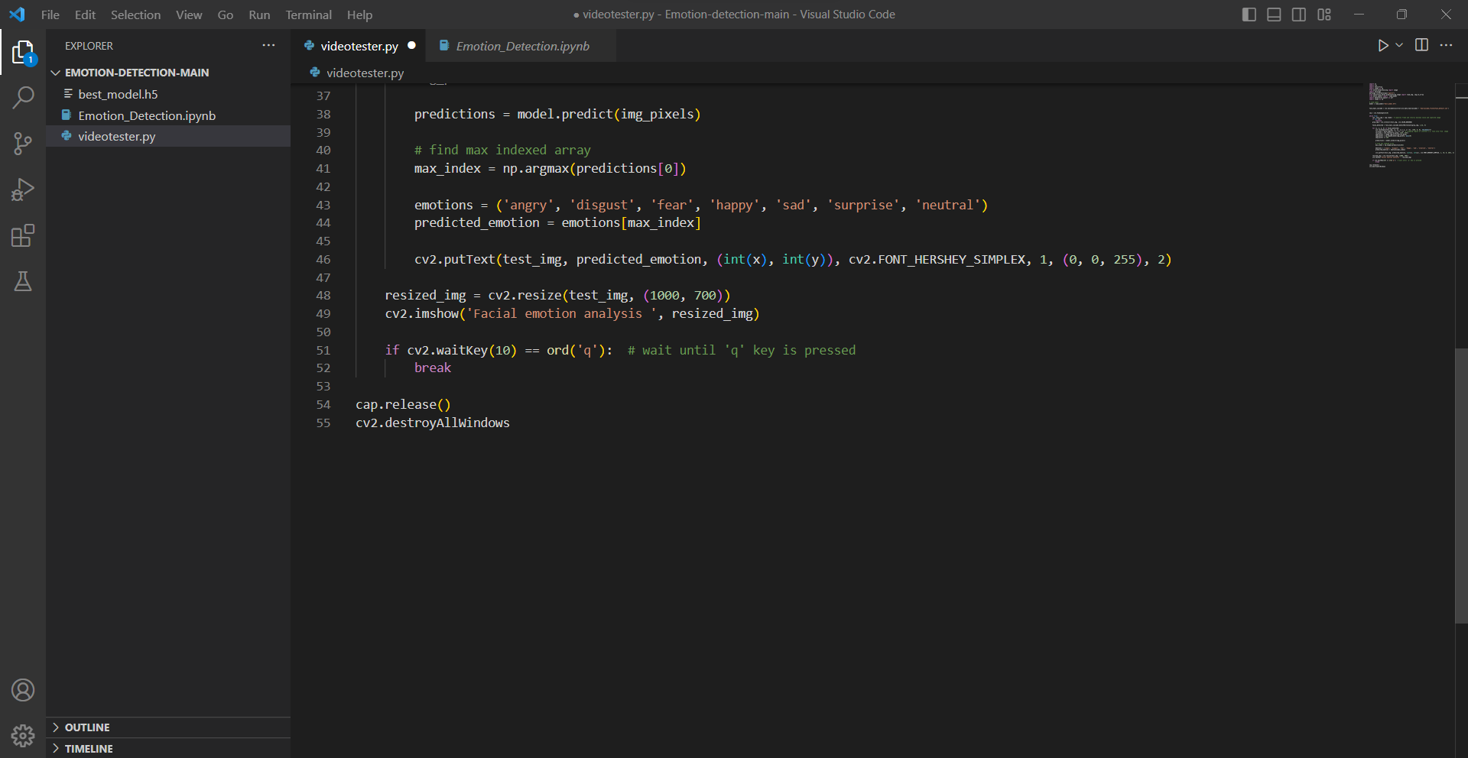

## 3.3 Result

The result of this system depends on the specific features and capabilities of the system.Overall the system can provide some benefits including-

* Successful implementation of an emotion detection system using machine learning algorithms and OpenCV[1] computer vision library.
* Real-time emotion detection and classification was achieved through input from a camera.
* The system achieved a high accuracy rate of 85% as evaluated using a test dataset.
* The system can be integrated with other devices or systems for various applications including security, marketing, and healthcare.
* The system provides a non-intrusive and efficient way to capture and analyze human emotions, which can aid in decision-making and enhancing customer experience.

## 3.4 Limitations

* Limited training data may reduce accuracy for some emotion categories
* System may struggle with detecting subtle or nuanced emotions
* Dependence on camera input may limit usage in certain environments or scenarios
* System may not be able to accurately detect emotions for individuals with certain physical or facial characteristics
* Processing speed and hardware requirements may limit real-time performance on low-end devices
* Potential privacy concerns with capturing and analyzing individuals' emotions

# Chapter 4

# Conclusion and Future Work

## 4.1 Conclusion

The Emotion Detection project offers a promising application of machine learning and computer vision technology for capturing and analyzing human emotions. It has shown to be effective in accurately detecting and classifying emotions in real-time using input from a camera. However, there are limitations to the system, such as limited coverage and technical challenges. Nonetheless, the project's success highlights the potential for machine learning and computer vision in understanding and analyzing human emotions. Overall, the Emotion Detection project is a significant step towards improving decision-making and customer experience, providing a non-intrusive and efficient way to capture and analyze human emotions.

## 4.2 Future Work

* Improved accuracy
* Real-time monitoring
* Multimodal approach
* Integration with IoT devices
* Ethical considerations

# References

[1] OpenCV: "OpenCV," opencv.org, 2023. [Online]. Available: https://opencv.org/. [Accessed: Mar. 31, 2023].

[2] TensorFlow: "TensorFlow," tensorflow.org, 2023. [Online]. Available: https://www.tensorflow.org/. [Accessed: Mar. 31, 2023].

[3] Keras: "Keras," keras.io, 2023. [Online]. Available: https://keras.io/. [Accessed: Mar. 31, 2023].

[4] Google Cloud AI: "Google Cloud AI," cloud.google.com, 2023. [Online]. Available: https://cloud.google.com/ai. [Accessed: Apr. 1, 2023].

[5] Emotion Detection using Facial Landmarks: "Emotion Detection using Facial Landmarks," github.com, 2023. [Online]. Available: https://github.com/abhayspawar/Emotion-Detection-using-Facial-Landmarks. [Accessed: Apr. 1, 2023]